 | 12.1.15 Editors - Geometry Nodes Editor - Header - Add Menu - Geometry - Write
Table of content
Detailed table of content 1
Add menu - Geometry - Write 2
Set Geometry Name 2
Set ID 2
Set Position 3
Set Selection – Tool Mode 4

Detailed table of content
Detailed table of content
Detailed table of content 1
Add menu - Geometry - Write 2
Set Geometry Name 2
Inputs 2
Geometry 2
Name 2
Outputs 2
Geometry 2
Set ID 2
Inputs 2
Geometry 2
Selection 2
ID 2
Outputs 3
Geometry 3
Set Position 3
Inputs 3
Geometry 3
Selection 3
Position 3
Offset 3
Outputs 3
Geometry 3
Set Selection – Tool Mode 4
Inputs 4
Geometry 4
Domain type 4
Selection 4
Outputs 4
Geometry 4

Add menu - Geometry - Write
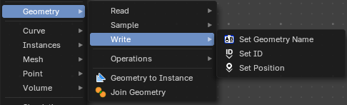
Here you find nodes to modify the geometry.

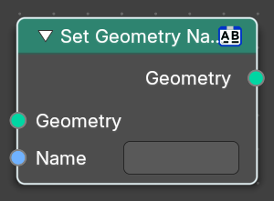
Set Geometry Name
Sets the name of the target geometry.

Inputs

Geometry
Geometry input.

Name
The name that you want to set

Outputs

Geometry
Geometry output.

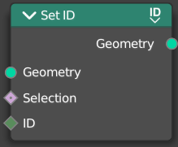
Set ID
Sets the ID of the target geometry.

Inputs

Geometry
Geometry input.

Selection
Selection input.

ID
ID Input

Outputs

Geometry
Geometry output.

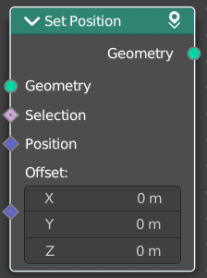
Set Position
The Set Position node controls the location of each point, the same way as controlling the position attribute. If the input geometry contains instances, this node will affect the location of the origin of each instance.
The input node for this data is the Position Node.

Inputs

Geometry
Geometry input.

Selection
Whether or not to change the position of each point or instance. True values mean the position will be changed, false values mean it will remain the same.

Position
The new position for selected elements. By default, this is the same as if the Position Node was connected, meaning the node will do nothing.

Offset
An optional translation for each point. This is evaluated at the same time as the Position input, meaning that fields evaluated for it will not reflect the changed position.

Outputs

Geometry
Geometry outputs.

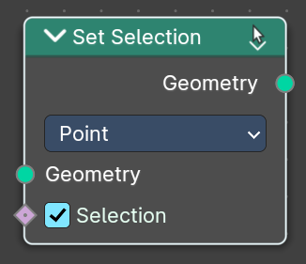
Set Selection – Tool Mode
Sets the selection of the edited geometry, for tool execution. When using this node, this set the selection of the active object to use in the Node Tree.
Example: You can deselect faces on an object in Edit Mode in the 3D View editor after you have run the Node Group Tool on only the selected faces. This can also be used in the execution of a tree to change the selection to run another chain of nodes on a different selection.

Inputs

Geometry
Geometry input.

Domain type
What domain the Set Selection node affects, be it points, edges, face or spline.

Selection
Whether or not to change the selection status (selected/deselected). True values mean the selection will be changed, false values mean it will remain the same.

Outputs

Geometry
Geometry outputs.

